SOFTWARE ENGINEERING ASSIGNMENT MSC (INFORMATION & COMPUTER SCIENCE)

Assignment 1

1. In a small town, trains arrive at the train station every hour on the hour every day of the week. They arrive on the half-hour, as well, only during rush hours. They also arrive on the half-hour all day Saturday but never on Sunday or holidays.
Assume the following variable assignments:
A = It is rush hour
B = It is Saturday
C =It is a holiday
D = It is Sunday

Write, in terms of A, B, C, and D, the Boolean Expression for
F = Trains arrive on the half-hour. Draw DFD for the problem and write C++ program to implement it.
Assignment 2

Write a program that
1)Reads image1.pgm in the RAW format and writes it in the ASCII format with the name image1_ascii.pgm .
2) Reads image2.ppm in the RAW format and writes it in the ASCII format with the image1_ascii.pgm
.
 | 
File:image1.pgm | File:image2.pgm

Assignment 3
Compute and plot (show the image and its histogram) the histogram of flower.pgm, swan.pgm and tools.pgm. Comment on what information can be discerned about the images from an examination of the histogram.

 |  | 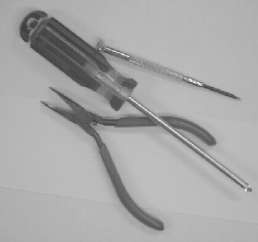
File: flower.pgm | File: swan.pgm | File: tools.pgm

Assignment 4
Student has to select the following automated system and perform the analysis and design of the system. They have to generate the documentation as per DFD and SRC (Any Two).

- Quiz System.
- Online ticket reservation system.
- Student marks analyzing system.
- Expert system to prescribe the medicines for the given symptoms.
- ATM system.
- Stock maintenance.
- Banking System. Library System.
- Online Book Shop System.
- University System.

Assignment 5
A c++ program that takes any program as input and counts the number of lines, blank lines, half lines, multiple lines
Assignment 6
A c++ program to count the number of global, extern, local variables of any input program
Assignment 7
A c++ program to count the no of recursive functions used in any input program

Assignment 8

A c++ program that checks whether all the loops are properly indented or not in any input program

